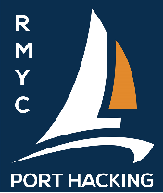 | Emergency Contact Form  Next of Kin (NOK)
Race Category 3 and 4 Crew Declaration Form

Details to be e-mailed to crew@sailing-rmycph.org.au.
Changes may be handed or radioed on VHF 73 to the starter no later than the warning signal for each Category 3 and Category 4 Race.

Yacht Name:
Sail Number:
Owner:
Mobile Phone Number:
Race:
Date:
Total POB:
Type of Boat
Distinguishing Marks

Crew Name: | AS Number | Emergency Name (NOK) | Emergency  Phone number

6.3 CREW START LIST (Cat 3 and 4 offshore races outside Bate Bay)
Each boat shall submit a list of crew members providing the name of the next of kin and phone number prior to the start.
- For Port Hacking Sailing (PHS) races this list must be emailed to crew@sailing-rmycph.org.au or changes notified to the starter on VHF 73 prior to the warning signal.
- For CSC combined races the list shall be E-mailed to crew@cronullasc.com prior to the race. Changes can be lodged in the CSC Club Letterbox or to the Starter no later than the first warning signal. A copy of this email will be forwarded automatically to RMYC.

